**Data Brief: Confirmed Unintentional/Undetermined1**

**Opioid-related2 Overdose Deaths Among Massachusetts**

**Residents – Demographic Data Highlights**

Massachusetts Department of Public Health POSTED: MAY 2016

2015.

This data brief highlights demographic data from confirmed overdose deaths from January 2015 through December



**Confirmed Unintentional/Undetermined1 Opioid-related Deaths by Gender: 2015**

|  |  |
| --- | --- |
| **Unintentional/Undetermined Opioid Deaths by Gender:**  **2015** | |
| Male | **1,048** |
| Female | **331** |
| **Total** | **1,379** |

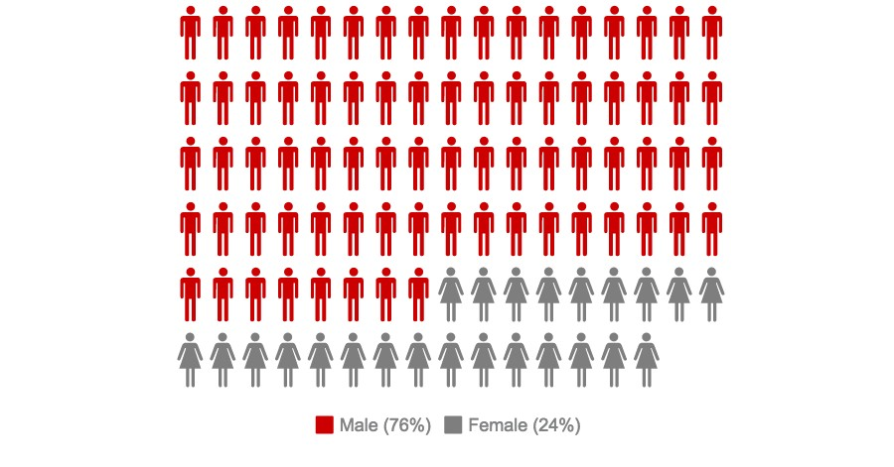

1 Unintentional poisoning/overdose deaths combine unintentional and undetermined intents to account for a change in death coding that occurred in 2005. Suicides are excluded from this analysis.

2 Opioids include heroin, opioid-based prescription painkillers, and other unspecified opioids.

**Confirmed Unintentional/Undetermined1 Opioid-related Deaths Compared to All Deaths by Age: 2015**

|  |  |  |  |  |  |  |  |  |  |
| --- | --- | --- | --- | --- | --- | --- | --- | --- | --- |
|  | **Deaths by Age: 2015** | | | | | | | | |
|  | **0-14** | **15-24** | **25-34** | **35-44** | **45-54** | **55-64** | **65+** | **Unknown** | **Total** |
| All Deaths | 393 | 481 | 1086 | 1270 | 3077 | 5995 | 44,055 | 5 | **56,362** |
| Confirmed Unintentional / Undetermined1 Opioid Deaths | 1 | 142 | 437 | 350 | 302 | 132 | 15 | 0 | **1,379** |

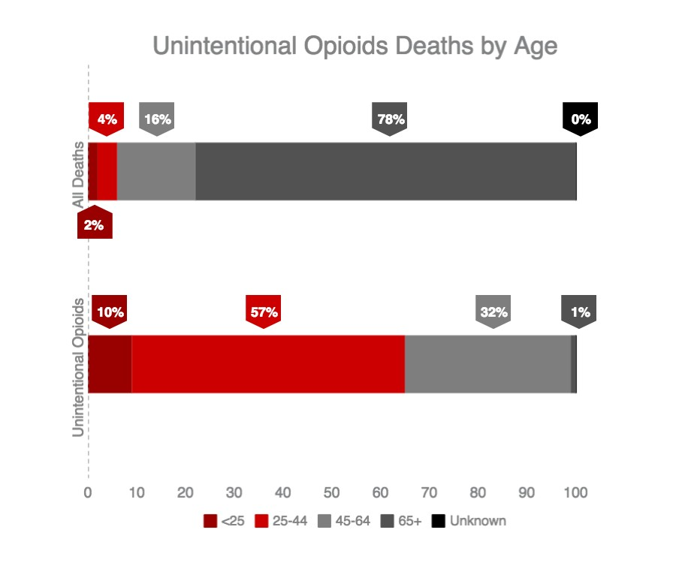

1 Unintentional poisoning/overdose deaths combine unintentional and undetermined intents to account for a change in death coding that occurred in 2005. Suicides are excluded from this analysis.

**Confirmed Unintentional/Undetermined1 Opioid-related Deaths Compared to All Deaths by Race: 2015**

|  |  |  |  |  |  |  |
| --- | --- | --- | --- | --- | --- | --- |
|  | **White**  **non- Hispanic** | **Black**  **non- Hispanic** | **Asian**  **non- Hispanic** | **Hispanic** | **Other/ Unknown** | **Total** |
| All Deaths | 50,413 | 2,343 | 1,066 | 1,996 | 504 | **56,362** |
| Unintentional/Undetermined1  Opioid Deaths | 1,162 | 63 | 6 | 125 | 23 | **1,379** |

**Unintentional/Undetermined1 opioid-related deaths, compared to all deaths: 2015**

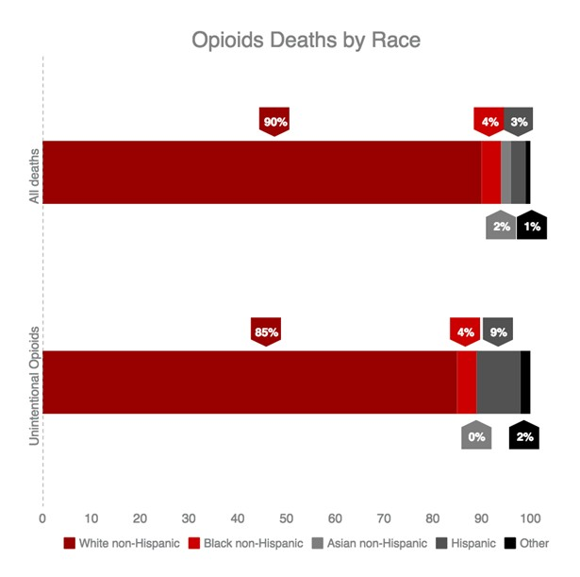

1 Unintentional poisoning/overdose deaths combine unintentional and undetermined intents to account for a change in death coding that occurred in 2005. Suicides are excluded from this analysis.

**Technical Notes**

2015 death data are preliminary and subject to updates. Case reviews of deaths are evaluated and updated on an ongoing basis. A large number of deaths have yet to be assigned final cause-of-death codes. The information

presented in this report only includes confirmed cases. Data updated on 03/31/2016.

**Source: Registry of Vital Records and Statistics, Massachusetts Department of Public Health**